Hong Kong Institute of Information Technology
Department of Media Technology
HD in Game Software Development (IT114107)

Agile Programming and Software Development Project (ITP4716M)
(2025/2026)

From Pixels to People: Creating Computer/Mobile Games to Strengthen Community and Family Bonds
Initial Report of Stellar Voyager: Spaceship

Date: 14/2/2026
Student: | Chan Yat Lok  Chen Yu Shiu  Cou Tsz Shing  Fung Shing Chun Eason

We declare that this is a group project and that no part of this submission has been copied from any other student’s work or from any other source except where due acknowledgement is made explicitly in the text, nor has any part been written for us by another person.

Student | Contribution to the project (%)  (Total 100%) | Signature
Chan Yat Lok | 25%
Chen Yu Shiu | 25%
Cou Tsz Shing | 25%
Fung Shing Chun Eason | 25%

Abstract:

In today’s multicultural world, playing card games is no more seen as a symbol of being childish. This phenomenon can be seen from the enormous popularity of the Hong Kong card game players’ club which is Player’s Club TCG. Regarding the online card games, there are mountain of lovers either such as Balatro and Slay the Spire. However, facing with the huge desire of multiplayer online Rougelike card game, there is a lack of a perfect and entertaining card game.

Therefore, we design an online Rougelike card game — Stellar Voyager: Spaceship so that we can foster the bond between players in the online card game community. In Stellar Voyager: Spaceship, players will act as an astronaut who drives the spaceship in the galaxy. During the journey, players will discover different mysterious planets. Then, players can choose to show different cards to decide the next step of movement such as visiting the shop on the space station or mining the ore on the planets or fighting with the alien. Different decisions will bring out different results, for example, the player's spaceship’s structure will be strengthened by choosing to mine ore. Finally, the player will finish a marvelous galaxy journey and bring a different impact to space.

In the beginning of this project, we will firstly focus on constructing the basic structure of the game with only single player. After that, we will make our game more well-rounded with more planets, more cards and even be capable of multiplayers. Our final goal is to strengthen the bond in the online card game player community through collaborating to finish an epic galaxy travel. The significance of this game is that it addresses the lack of multiplayer online card games.

Contents
Abstract: 2

Introduction: 4
The Goals of the Game: 4
Document Structure: 8

Game Design: 13
Basic constraints and requirements: 13
Design Thinking --- Empathize: 15
Design Thinking --- Define: 19
Design Thinking --- Ideate 22

Project Plan 31
Schedule: 31
Milestone description: 34
Action Plan for (the Prototype for candidate): 35
Feedback: 36

Appendices 37
Workload Distribution: 37
Budget Estimation: 39

References 40

Introduction:
The Goals of the Game:
Game description:

In today’s multicultural world, playing card games is no more seen as a symbol of being childish. This phenomenon can be seen from the enormous popularity of the Hong Kong card game players’ club which is Player’s Club TCG. Regarding the online card games, there are mountains of lovers either such as Balatro and Slay the Spire. However, facing the huge desire of multiplayer online Rougelike card games, there is a lack of a perfect and entertaining card game.

Therefore, we design an online Rougelike card game — Stellar Voyager: Spaceship so that we can foster the bond between players in the online card game community. In Stellar Voyager: Spaceship, players will act as an astronaut who drives the spaceship in the galaxy. During the journey, players will discover different mysterious planets. Then, players can choose to show different cards to decide the next step of movement such as visiting the shop on the space station or mining the ore on the planets or fighting with the alien. Different decisions will bring out different results, for example, the player's spaceship’s structure will be strengthened by choosing to mine ore. Finally, the player will finish a marvelous galaxy journey and bring a different impact to space.

In the beginning of this project, we will firstly focus on constructing the basic structure of the game with only single player. After that, we will make our game more well-rounded with more planets, more cards and even be capable of multiplayers. Our final goal is to strengthen the bond in the online card game player community through collaborating to finish an epic galaxy travel. The significance of this game is that it addresses the lack of multiplayer online card games.

Game genre:

Roguelike Deck-Builder
This is the core genre. Stellar Voyager: Spaceship revolves around players using a deck of cards to make strategic decisions (movement, actions, encounters). The "limited time period for decision" introduces a turn-based or real-time strategy element common in deck-builders like Slay the Spire. The procedural discovery of planets and permanent upgrades (strengthened ship, buffs) after each run solidifies the roguelike structure.

Game map genre:

Additionally, the map of this game is similar with Stellaris

The scope of the game:

The scope of Stellar Voyager: Spaceship simulates the whole galaxy, players can discover the planets he wants. After the initial design of the game, we would add on the Rougelike elements which will randomize the planets, the ore on the planet and the aliens that need to fight with.

Target Player:

Our final goal is to strengthen the bond in the online card game player community through collaborating to finish an epic galaxy travel. The significance of this game is that it addresses the lack of multiplayer online card games. The suggested age limit should be 16+ as the content of the game contains fighting scenes and little bloody scenes but without any erotic scenes.

Comparing with other existing games:

Game | Similarities | Key Difference (What makes Stellar Voyager: Spaceship different)
Slay the Spire | Core roguelike deck-building loop; map navigation with choice nodes; turn-based card combat against enemies and bosses. | Decision Mechanic: In Slay the Spire, you move freely between nodes. In Stellar Voyager: Spaceship, your movement and action are one, governed by playing cards from a shared deck. The real-time decision pressure adds a unique layer of urgency and spatial strategy. The thematic integration (cards represent ship actions, upgrades are physical ship modules) is far more immersive.
Game | Similarities | Key Difference (What makes Stellar Voyager: Spaceship different)
FTL: Faster Than Light | Space-themed roguelike; sector-by-sector exploration; managing ship systems; consequential random events; a final boss. | Core Gameplay: FTL is a real-time tactical simulator. Stellar Voyager: Spaceship replaces direct ship management with strategic card play. Your "crew" and "systems" are abstracted into your deck and upgrades, creating a more accessible but equally deep puzzle focused on hand management and long-term planning.
Monster Train | Deck-building with heavy emphasis on synergistic combos; multi-lane combat; post-fight upgrades and path choices. | Setting & Pacing: While Monster Train is about defending a static point, Stellar Voyager: Spaceship is about forward-moving exploration and survival. The time-limited decisions on the map create a distinct pressure not found in Monster Train's more contemplative strategic layer. The space adventure theme offers a different narrative and visual appeal.
Void Bastards | Humorous space-themed roguelike; resource management; strategic navigation; upgrading your gear and ship. | Genre & Interaction: Void Bastards is a first-person shooter. Stellar Voyager: Spaceship replaces moment-to-moment shooting with turn-based card combat, appealing to players who prefer cerebral strategy over reflexes. Both share the "scavenge and upgrade your ship" fantasy, but deliver it through entirely different gameplay.

Pros and Cons regarding of Stellar Voyager: Spaceship:

Pros:

Target Players: The game targets a dedicated and proven market segment with strong appeal to fans of roguelikes, strategic deck-builders, and space-themed simulations. Its mechanics will attract players aged 16+ who enjoy tactical planning, resource management, and mastering complex systems. The core loop is also highly suitable for busy adults seeking meaningful gameplay in short, fun-to-play-again sessions.

Compared with Existing Games: Stellar Voyager: Spaceship stands out by synthesizing proven mechanics into a fresh, thematic experience. Its core loop is reminiscent of Slay the Spire and Monster Train, but it innovates by making the strategic map navigation itself a direct, time-pressured card-play puzzle. This creates a unique blend of spatial and deck-management strategy not seen in its peers. While FTL: Faster Than Light shares the space roguelike theme, Stellar Voyager: Spaceship replaces real-time crisis management with more cerebral, turn-based card strategy, offering a distinct flavour of challenge.

Strengthen Bond or Not? While primarily a single-player experience, Stellar Voyager: Spaceship has excellent potential for indirect social bonding and community engagement. The game’s deep customization (ship builds, card synergies) and high replayability naturally foster discussion. For example, players will share stories of incredible runs, post screenshots of their unique ship configurations, and collaboratively solve optimal strategies for defeating tough bosses on forums and social media, creating a knowledgeable and passionate community.

Cons:

Contents of the Game enjoyable or tedious? The enjoyment is highly dependent on perfect tuning of its core mechanics. The innovative "time-limited card play" for decisions is a double-edged sword. If balanced poorly, it could force rushed, unsatisfying choices, turning strategic planning into stressful guesswork and making the game feel tedious and unfair. Furthermore, the need to balance cards across multiple functions (movement, mining, combat) is a monumental task. If certain card types or builds become obviously superior, it could reduce the diverse, exploratory gameplay to a repetitive "meta," undermining the joy of discovery and making subsequent runs feel samey.

Risk of Early-Game Frustration and Run Variance: The roguelike structure combined with card draw RNG creates a significant risk of frustrating early-game experiences. A new player with a poor starting hand or an unlucky first encounter, compounded by the time pressure, could face a swift, demoralizing game over before they understand the systems. This "feels bad" moment could deter players from continuing. Ensuring the early game is forgiving enough to teach but challenging enough to engage will be a critical and difficult design hurdle.
Document Structure:
- Abstract:

-Brief overview of the project
-Problem statement: Lack of perfect multiplayer online Roguelike card games
-Solution: Stellar Voyager: Spaceship --- an online Roguelike deck-building game
-Core gameplay: Astronaut navigating galaxy, making card-based decisions
-Project phases: Single-player prototype --- Multiplayer expansion
-Significance: Fostering community bonds in online card game communities

- Introduction:

3.1 Game Goals & Description:

-Detailed game narrative and core loop
-Player role: Astronaut navigating spaceship through galaxy
-Decision-making via card play
-Time-limited strategic choices
-Run-based progression with permanent upgrades

3.2 Game Genre:

-Primary: Roguelike Deck-Builder
-Secondary Elements: Strategic Map Navigation (Stellaris-style)
-Turn-based/Real-time hybrid decision system

3.3 Scope of the Game:

-Simulated galaxy exploration
-Procedural generation of planets, resources, encounters
-Progressive development plan (MVP → Full version)

3.4 Target Players:

-Age: 16+ (mild violence, no erotic content)
-Audience: Fans of strategic card games, roguelikes, space simulations
-Community focus: Strengthening bonds through shared experiences

- Competitive Analysis:

4.1 Pros and Cons of Stellar Voyager: Spaceship:

Pros:

-Unique card-based movement/action integration
-Strong community potential
-Innovative time-pressure mechanics
-Thematic consistency

Cons:

-Balance challenges (multi-purpose cards)
-Early-game frustration risks
-Learning curve complexity

- Document Structure:

-Overview of documentation organization
-Reference to subsequent sections

- Game Design:

  - Basic Constraints & Requirements:

Constraints:

-Time: 7.5-month development cycle
-Team: 4 members with specific roles
-Technical: Client-only → 3-tier architecture evolution
-Content: 150 cards, 5 sectors, 20-25 enemies at launch
-Performance: 30 FPS minimum, <4GB RAM usage

Requirements:

-Zero critical bugs at launch
-Consistent art style
-Responsive controls with clear feedback

6.2 Design Thinking Process:

Empathize:

-Player journey analysis for reference games
-Emotional arcs and pain points
-Universal insights for deck-building roguelike genre

Define:

-Key problems reframed as opportunities:
---Time Pressure Problem --- "Captain's Dilemma" system
---Balance & Learning Curve --- "Ship's Log" learning layer
---Repetition Problem --- "Galactic Legacy" system
-Additional opportunities:
---"Synergy Discovery" engine
---"Controlled Chaos" difficulty system

Ideate:

Four team proposals evaluated:
-Chan Yat Lok: Hearthstone Tales
-Fung Shing Chun: Starforge Chronicles
-Cou Tsz Shing: Town of Masks
-Chen Yu Shiu: Forge of Fate (selected)

Convergent Thinking & Final Decision:

-Evaluation criteria: Scope, innovation, feasibility
-Selected proposal: Chen Yu Shiu's card game concept
-Rationale: Controlled development, strong innovation, optimal risk profile

- Project Plan:

7.1 Schedule & Time:

-Month 1-2: Project Launch (Initial Report)
-Month 2-4: Knowledge Building (Interim Report, Game Design Document, Prototype)
-Month 4-7: Development & Critique (Releasable Game, Data Governance Policy)
-Month 7-7.5: Presentation (Final Report, Demonstration)

7.2 Milestones:

-Game Outline Finalized (12-03-26)
-Prototype Completed (02-06-26)
-Closed Alpha Ready (17-06-26)
-Closed Beta Ready (30-07-26)
-Open Testing Ready (19-08-26)

7.3 Action Plan for Prototype (7-8 Weeks):

Phase 1: Core Foundation (Week 1-3)
---Draggable card system
---Basic node types
---Simple UI implementation
Phase 2: Core Loop (Week 3-6)
---Complete sector with win/lose conditions
---All card types functional
---Basic combat system
Phase 3: Polish & Test (Week 6-8)
---Bug fixing and balance
---External playtesting preparation
---Performance optimization

7.4 Feedback Strategy:

-Critical questions about core mechanics
-Specific mechanic testing
-Usability and fun factor metrics

- Appendices:

  - Workload Distribution:

-Chan Yat Lok: Unity Programming, Modeling, Report Writing
-Chen Yu Shiu: Lead Programming, Animation, Game Design
-Fung Shing Chun: 3D Art, Presentation, User Testing
-Cou Tsz Shing: Support Programming, Modeling, Effects

8.2Budget Estimation:

Category | Cost (HKD) | Notes
Software | $2,000 | Basic tools
Assets | $2,000 | Minimal purchases
Marketing | $780 | Steam fee only
Contingency | $1000 | Buffer
Total | $5,780

  - Additional Supporting Materials:

-Concept art sketches
-Card design templates
-Technical architecture diagrams
-Playtesting feedback forms
-Risk assessment matrix
-References and bibliography

Game Design:
Basic constraints and requirements:
We plan to finish the project in 7.5 months, client-only architecture for single-player, but 3-tiers architecture (client-server-database) is needed for multiplayer,currently available technologies (3D printer, AR, VR) and resources that are available (school teaching materials, our teachers, our classmates, school computers, and books, printers etc. in our school study and learning center)

Constraint:

Time Constraint:

Month1-2: Stage: Launch Project. Have to submit the initial report
Month2-4: Stage: Build Knowledge. Have to submit the interim report, game design document,3D models and game prototype
Month4-7: Stage: Develop and Critique. Have to submit releasable game, data governance policy document
Month7-7.5: Stage: Present Products Publicly. Have to submit the final report and project presentation and demonstration

Skill Constraint:

Small Team: 4 members (likely cross-functional)
Roles needed: Game Designer, Programmer(2x), Artist(2D/3D&UI), Sound Designer
Skill Limitations: No AAA-level team, limited 3D and programming capabilities

Balance & Testing Constraints:

Limited Playtesting: Can't afford large-scale paid testing
Community Reliance: Must gather feedback from Discord/Steam forums
Balance Iteration: Must be data-driven with logging system

Scope Constraints:

Maximum Card Count: 150 cards at launch
Sector Count: 5 distinct sectors (biomes) with 1 final boss sector
Run Length: 30-45 minutes for experienced players
Enemy Variety: 20-25 unique enemy types

Requirements:

Performance requirements:

Target Specs: Run smoothly on general hardware
Load Times: Under 15 seconds for initial load
Memory: Under 4GB RAM usage
Frame Rate: Consistent at least 30 FPS during gameplay

Polish requirements:

Zero critical bugs at launch
Consistent art style across all assets
Responsive controls with clear feedback

Design Thinking --- Empathize:

- Slay the Spire Player Experience:

The Player's Journey:

SodaPrison (player’s name), one of the superfans of Slay the Spire who has already played this game more than 1,380.4 hours, commented” I have too much time in this game to give an unbiased review, but I have enough time in enough different rogues to be able to say this is a top 3. Been playing since early access and there was and is a clear development path in prioritizing the finely tuned balance of the math & mechanics that make it so hard to drop & so easy to come back to. Informed decision making is often rewarded. Item combos are plentiful & form from natural synergies instead of bonus effects from specific triggers. After 1000 hours I'm still thinking instead of going through the motions.”

Emotional Arc:

Hour 1: Excited experimentation → "What if I combine this 'Echo Form' with 'Electrodynamics'?"
Hour 2: Frustrated learning → Dies to the second boss because their defense cards weren't upgraded.
Hour 3: Triumphant discovery → Unlocks a new card that perfectly synergizes with their playstyle.

Pain Points Players Express:

"I hate when I get unlucky card draws against that one enemy who scales damage"
"Sometimes I feel like I'm just watching my health go down with no way to stop it"
"I wish I could redo that last turn—I misclicked and played the wrong card"

What Players Love:

The "aha!" moment when a card combo clicks
Seeing incremental progress (new cards unlocked, Ascension levels climbed)
The community aspect—sharing broken builds on Reddit

- FTL: Faster Than Light Player Experience

The Player’s Journey:

bigbabalaba(player’s name), one of the biggest fans of FTL: Faster Than Light Player Experience who has already played this game more than 21.9 hours, commented” Call me crazy, but FTL is ahem - MY FAVORITE GAME OF ALL TIME. What?! you say? HOW??!! you ask? Well, I’ll tell you. I’ve loved a ton of games, many of them I’d describe as “perfect games”, but nothing has brought me as many hours of pure, unadulterated joy as FTL. Hundreds of hours. My 12-year-old son adores this game and he started playing at age 7 (he once had me tweet at the Subset Games guys with a photo of a huge enemy vessel where he’d lit every room on fire). My wife loves this game, it’s one of 3 games she plays on loop.”

Emotional Arc:

Moments of Calm: Traveling between sectors, managing resources
Sudden Panic: A missile hits the oxygen system while she's fighting a boarding party
Bitter Defeat: Reaches the final boss for the 15th time, but her weapons system gets hacked

Pain Points Players Express:

"Random events can completely ruin a run—why did I get boarded by mantis in sector 2?"
"The final boss feels unfairly difficult compared to everything else"
"I wish I could save mid-run—sometimes I need to stop playing"

What Players Love:

The emergent storytelling ("Remember when we barely escaped that sun with 1 hull left?")
The deep system management (power distribution, crew skills, upgrade paths)
The incredible modding community

- Monster Train Player Experience:

The Player’s Journey:

sethbrundle79(player’s name), one of the fans of Monster Train who has played this game for more than 67.3 hours, commented” Fun game when it works. Music is upbeat. Some compare this game to slay the spire. This game is much easier. Depending on the choices you make you can get constant similar positive results, less dependent on RNG. Game can be played in short bursts for people who don't have a lot of time to play. Fair waning that here is a constant bug that causes the game to hang or crash on start up due to the FMV that plays when the game starts. This is a known issue that still persists years later. 3.5 stars out of 5.”

Emotional Arc:

Confident Setup: Carefully placing units across three floors
Tense Execution: Watching enemy waves climb, praying his defenses hold
Community Celebration: Chat explodes when he beats the final boss with 1 Pyre health left

Pain Points Players Express:

"Some clan combinations feel much weaker than others"
"The daily challenge sometimes has impossible modifiers"
"I wish there was more variety in the final bosses"

What Players Love:

The incredible power fantasy (some runs get completely broken in fun ways)
The quick run times (30-45 minutes vs Slay the Spire's 60-90)
The clear visual feedback (seeing damage numbers pop, units evolving)

- Universal Player Insights for the Deck-Building Rougelike Genre:

Cognitive Load Patterns:

Players experience decision fatigue around the 45-minute mark
Most enjoyment comes from mastering systems, not from narrative
The sweet spot is challenging but fair—players accept RNG if they feel they could have played better

Learning Progression:

First 2 hours: "I have no idea what I'm doing, but it's fun"
Hours 3-10: "I understand the basics but keep dying"
Hours 11-30: "I can consistently win with my favorite strategy"
30+ hours: "I'm experimenting with weird builds and climbing difficulty levels"

Social-Emotional Needs:

Competence: "I want to feel like I'm getting better"
Autonomy: "I want my choices to matter and create unique outcomes"
Relatedness: "I want to share my discoveries and learn from others"
Narrative: "I want my runs to tell interesting stories, even if scripted"

Design Thinking --- Define:

Key Problems to Solve (Reframed as Opportunities):

- TIME PRESSURE PROBLEM

Player Expression: "I hate feeling rushed into mistakes rather than challenged strategically."

Reframed Need: Players need meaningful tension, not arbitrary stress. The clock should create dramatic moments of choice, not panic-induced errors.

Insight: The timer shouldn't just be a countdown—it should be a strategic resource. What if "time" was a currency players could spend or save?

- BALANCE & LEARNING CURVE PROBLEM

Player Expression: "New players get destroyed by bad RNG and never come back."
Reframed Need: Players need clear cause-and-effect feedback to learn from mistakes, not confusing, sudden deaths.

Insight: Progressive transparency—the game should show WHY things happened. "You died because your shield card came 3 turns too late" not just "You died."

- REPETITION PROBLEM

Player Expression: "After 20 runs, I'm just doing the same optimized path."
Reframed Need: Players need emergent storytelling and unique run identities that make each voyage memorable.

Insight: The "story" shouldn't be scripted—it should emerge from player choices + game systems interacting. Like how FTL creates "remember when" moments.

Defined Design Opportunities:

OPPORTUNITY 1: The "Captain's Dilemma" System

Instead of: A simple countdown timer
We Could: Make time a spendable resource called "Bridge Time" or "Command Points."

-Certain powerful cards cost more Bridge Time to play
-Players can bank unused time for difficult sectors
-Critical decisions (like changing course mid-sector) consume large chunks of time
-Result: Players feel like they're managing their command efficiency, not racing a clock

OPPORTUNITY 2: The "Ship's Log" Learning Layer

Instead of: Mysterious deaths and confusing mechanics
We Could: Implement a post-run analysis system that highlights:

-Which decisions created chain reactions
-Alternative paths you could have taken
-"What if" scenarios based on different card plays
-Result: Even failed runs feel educational and players learn systems organically

OPPORTUNITY 3: The "Galactic Legacy" System

Instead of: Simple unlockable new starting cards
We Could: Create persistent galaxy changes based on run outcomes:

-Defeat a pirate lord? That sector becomes safer for future runs
-Establish a trade route? Get discounts at certain stations permanently
-Fail spectacularly? Create a "graveyard sector" that's more dangerous but has better loot
-Result: Players feel their decisions matter beyond one run, creating personal narrative

OPPORTUNITY 4: The "Synergy Discovery" Engine

Instead of: Predetermined card combos
We Could: Design cards that interact in unexpected, emergent ways:

-A mining laser card + sensor array card = mineral scanner
-An engine boost card + shield card = emergency ramming maneuver
-Result: Players experience genuine "Eureka!" moments and share discoveries

Defined success criteria:

Our game will be successful if…

-After losing, 90% of players understand WHY they lost and have ideas for next time
-Players can describe their "most memorable run" with specific story beats
-The community shares "discovered combos" we didn't explicitly design
-Players voluntarily choose harder challenges because they're fun, not just for achievement points
-The time mechanic creates "epic stories" ("I barely escaped with 2 seconds left!") not complaints ("The timer is too short")

Framing statement:

"Stellar Voyager isn't about racing against a clock—it's about making every second count. You're not just playing cards; you're making command decisions that echo through the galaxy. Each run writes a chapter in your captain's legacy, where even failures teach you how to command better next time."

This reframe transforms:

Timer --- Command Resource
Randomness --- Strategic Uncertainty
Repetition --- Evolving Galaxy
Difficulty --- Meaningful Challenge
Death --- Learning Opportunity

Design Thinking --- Ideate
Concentrate on idea generation (divergent thinking):

Chan Yat Lok:

Proposed Game: "Hearthstone Tales"

Description: A digital board game where families/neighbors work together to build a shared storybook town. Players complete real-world "connection quests" (e.g., take photos together after events, cook together) to unlock in-game resources and story chapters.

Genre: Cooperative Simulation / Digital Board Game.

Scope: A mobile app with core town-building, a quest log, and a shared story library.

Target Players: Families with 8+ kids, and anyone who would like to know more about his local community and strengthen the bond between him and his community.

Comparison with Existing Games:
Unlike competitive apps (e.g., Monopoly on mobile) or isolated builders (e.g., Animal Crossing), Hearthstone Tales needs Players to build the virtual community together.

Pros & Cons:
This game can foster real connection rather than just screen time. It is fun and inclusive for all ages. However, it really needs players to be buy-in for offline tasks, otherwise, it is meaningless without participation.

Fung Shing Chun Eason:

Players control a basic spaceship at first.
Players can choose where to go in a big map.
e.g. Planets, Spacebase or others spaceship
Player need fuel to move

When players come to a new place, they can choose to enter the place or stay in space.
Players can collect resources, discarded parts in space or mined meteorites.

Normal resources can be collected like metal, missing goods, weapons,and broken parts of spaceships.

One place has different resources like some special spices, ores.

build on place
e.g. Shop,Factory,Guild.
Plant:Players can use build on the planet
buy or sell resource

Build:
Shop: Players can buy weapon,spaceship parts or resource
Factory:upgrade weapon,spaceship parts
Guild:take quest

Ship:
Ships need to have a core, engine, control plane
Core to create electricity,the ship needs more electricity.
The engine makes the ship move.
The control plane controls the direction.

Craft:
Players can craft different weapons,armor ,modification and upgrade their ship.

Battle:
card different Players can get cards at first.
attack, skill, move, cards.

Cou Tsz Shing:

Introduction: A multiplayer PvP game with 2 or more players. The scene is in a small town. Players will be given an identity at the start of the game, such as a deliveryman or truck driver. At the same time, a lot of NPC professions will appear on the field. Players need to perform actions consistent with their profession, but there are also hidden quests known only to themselves. Players can use weapons to eliminate other players, but if they eliminate an NPC, they are eliminated themselves. Players need to complete their own hidden quest first or identify other players to win.

Detail: In the scene can places some useful items to help players complete tasks or find other players. This can increase the fun of the game. Also, Each NPC has randomized action logic, but all actions will conform to their professional behavior. Increases the game's replayability.

Chen Yu Shiu:

Game type:card game

Game:Player have some points to get a deck(20+1cards) at first
20cards can be chosen in the card pool by using some points
Left some point can use to design the only card
The only cards can add some effect(positive/negative), the effect have different pt

Players use the deck to defeat enemies,in the end they will have a boss,defeat the boss will win.

In stage:have different room,can:[get pt]/[get card]/[change the effect of only card]/[get special effect]/[get consumables]/[get heal]/[fight with elite/normal enemy]

Stage difficult (when player wins,can increase the difficult,increase enemy strength/player will have some debuff,player also will unlock new cards/new only card effect)

Evaluate different proposals (convergent thinking):

Regarding Chan Yat Lok’s game proposal --- Hearthstone Tales:

Pros:

Large scope of players: It features a large scope of players which include 8+ kids to adults and anyone who would like to strengthen his relationship with his neighbors or family.

Uniqueness: Hearthstone Tales is unique among the game market, compared with the existing games in the market, Sims 4 or Monopoly Go! may be the most similar type of game. However, none of the above games need players to interact with the real world. Pokemon Go may be the most popular game that contains real world interaction, but it lacks a significant impact of fostering the relationship between communities.

Cons:

Contents of the game: Hearthstone Tales needs players to be actively interested in accomplishing offline tasks in the beginning, otherwise, it will be meaningless and tedious without sincere participation. In the game, the completion of different tasks will provide players a sense of achievement by showing a diverse community’s building model. However, it still needs the players to be determined to throw themselves into offline tasks.

Regarding Fung Shing Chun Eason’s game proposal:

Pros:

The game has a broad audience: it attracts fans of open-world sandbox games, space discovery lovers, such as Elite Dangerous and No Man’s Sky. Additionally, it is captivating for those who enjoy decision-making and deck-building elements. Its spaceship-building and resource discovery can attract either creative builders or strategic players.

Uniqueness: the proposal smartly gathers successful elements from several popular genres of games. The open-space exploration and resource discovery echo No Man’s Sky and Elite Dangerous. The card-based fighting system contains the special element from Slay the Spire. This proposal of mixing different interesting elements into the game fills the gap of the game market.

Strong potential for community bonding: Players can collaborate to build factories or accommodation on the planets. Also, players can accomplish quests together. For example, a group of friends could specialize — one as a miner, one as a factory manager, one as a captain of the spaceship — and work together to create a powerful teamwork.

Cons:

Contents of the game may be tedious: The proposal lists many systems (exploration, mining, crafting, shop management) which could feel like a boring daily routine if there is no exceptional balancing and progression. Luckily, there is a way to improve the situation. The initial experience is critical. By providing immediate rewards, players can avoid feeling lost in a vast, demanding universe.

Potential for Player Frustration:
The game’s economy and survival elements could lead to frustration. Running out of fuel in empty space could create negative “dead time”. Moreover, the card-based battle may be somewhat unique.

Regarding Cou Tsz Shing’s game proposal:

Pros:

The game targets a specific and engaged audience of players who enjoy social deduction, hidden role, and PvP games. It appeals directly to fans of Among Us, Project Winter, and Town of Salem, but with a more active, open-world twist. It also has strong potential for streamers and content creators due to its emergent, player-driven stories and bluffing mechanics.

Compare with Existing Games: The proposal innovates within a popular genre. While Among Us is confined to a spaceship with simple tasks, Town of Masks expands the concept into a dynamic open-world "small town" where blending in is more complex. The use of profession-specific actions and randomized NPC logic is more sophisticated than typical "task completion," making it closer to a Hitman or Deathloop scenario blended with social deduction. The core penalty—elimination for killing an NPC—is a brilliant rule that forces careful observation and raises the stakes significantly compared to games where NPCs are merely set dressing.

Strengthen Bond or Not? The game is explicitly designed to strengthen (or test) bonds through its multiplayer PvP and deception mechanics. It creates intense social situations where players must read their friends' behavior, bluff convincingly, and form temporary alliances. For example, a player pretending to be a deliveryman might offer to "help" another player with their task, only to betray them once their own hidden objective is complete. This generates memorable, shared stories and laughter, perfect for party settings or close-knit gaming groups.

Cons:

Contents of the Game: Enjoyable or Tedious? The enjoyment is highly fragile and dependent on player engagement and game balance. If the hidden quests are too obscure or difficult to complete alone, players may feel lost and resort to random violence, breaking the game's intended social stealth loop. The initial phase of figuring out professions and observing NPC logic could be slow or confusing, leading to a tedious start. The fun relies entirely on players understanding and committing to the "blending in" premise; without that, it devolves into a chaotic and unsatisfying deathmatch.

Risk of Player Frustration and Stagnation: There is a high risk of frustration from misidentification and passive gameplay. A player who is incorrectly identified and killed early may have to wait a long time for the round to end, leading to a poor experience. Furthermore, if players become too cautious, the game could stagnate with everyone overly focused on their solo tasks, reducing player interaction and the thrilling PvP tension. Balancing the hidden quests to encourage both goal-oriented play and player interaction will be the game's greatest design challenge.

Regarding Chen Yu Shiu’s Game Proposal:

Pros:

Target Players: This game has a sharp and dedicated target audience. It appeals directly to strategic deck-building enthusiasts, fans of roguelike card games like Slay the Spire, Monster Train, and Gordian Quest. Players who enjoy deep customization, meta-progression, and optimizing complex systems will be its core demographic. The "design your own card" hook is particularly attractive to players who enjoy theory-crafting and personal expression within a game's rules.

Compare with Existing Games: The proposal builds intelligently upon a proven and popular genre while adding a key innovative mechanic. The core loop of navigating a map, battling enemies, and upgrading a deck is a direct and successful formula from Slay the Spire. However, the addition of a customizable "Only Card," designed by the player with a point-budget system for positive/negative effects, is a significant and compelling twist. This moves beyond simply choosing from a pre-set pool and into the territory of games like Magic: The Gathering's deck personalization or Inscryption's card modification, creating a powerful sense of ownership and unique strategy.

Strengthen Bond or Not? While primarily a single-player experience, the game has strong potential for community bonding indirectly. The "Only Card" system is a fantastic catalyst for discussion. Players can share their uniquely designed cards, synergistic decks, and strategies for tackling higher difficulties on forums and social media. For example, a player might create a card with a powerful positive effect balanced by a crippling negative one, then design an entire deck to mitigate that weakness, creating a "build" story worth sharing. This fosters a knowledgeable and engaged community.

Cons:

Contents of the Game: Enjoyable or Tedious? The risk lies in the game's complexity barrier and potential for optimization to ruin fun. The initial phase of spending points to draft a 20-card deck and design a custom card could be overwhelming for new players, leading to analysis paralysis and a tedious start if not expertly tutorialized. Furthermore, the "Only Card" system, while a major pro, is a double-edged sword. If the point costs for effects are not perfectly balanced, players will quickly identify a single "meta" or overpowered card design, making every run feel samey and reducing the intended creativity to a tedious calculation. The joy of discovery could be replaced by the tedium of min-maxing.

Final Decision: Select Chen Yu Shiu's Card Game Proposal

Primary Reasons for Selection:

Controlled Development, Scalable Depth: The game is built for iterative development and natural expansion. A Minimum Viable Product (MVP) with a small card pool, a few enemy types, and a basic "Only Card" creator can be built, tested, and fun quickly. From there, content (new cards, enemies, bosses, effects) can be added modularly to create depth and replayability. This is far more manageable than balancing the emergent social dynamics of Cou Tsz Shing's game or the vast, interdependent systems (economy, ship-building, exploration) of Fung Shing Chun's game.

Strongest Core Innovation with Built-in "Hook": While all proposals had unique ideas, Chen Yu Shiu's "Only Card" system is a standout, marketable hook that is deeply integrated into gameplay. It provides immediate player agency, personal expression, and a compelling reason to discuss the game. This single innovative mechanic, layered on a proven genre foundation, offers the best balance of "familiar yet fresh" that attracts players.

Optimal Risk vs. Reward Profile: This project carries the lowest risk of fundamental design failure.

---Chan Yat Lok's (Hearthstone Tales): Critically dependent on unproven player behavior (sincere offline task completion) and has high logistical/technical hurdles (GPS, real-world integration).

---Cou Tsz Shing's (Town of Masks): Live multiplayer social deduction is notoriously difficult to balance; fun is fragile and requires a critical mass of committed players, which is hard to guarantee.

---Fung Shing Chun's (Starforge Chronicles): An "everything sim" with massive scope; integrating ship-building, resource management, exploration, and card combat is a high risk for feature creep, imbalance, and an unfinished product.

---Chen Yu Shiu's (Forge of Fate): The risks (complexity barrier, balance) are tuneable through data and iteration on numbers and card text, not fundamental to the concept.

Comparison and Rationale Against Other Proposals:

Vs. Chan Yat Lok's "Hearthstone Tales": While socially ambitious, its dependency on extrinsic real-world motivation makes its core loop unreliable and difficult to test. Chen Yu Shiu's game creates its compelling world entirely within the game, guaranteeing a controlled experience.

Vs. Fung Shing Chun's "Starforge Chronicles": This is a fantastic idea for a large studio or a sequel. Its scope is simply too vast for a single project. Chen Yu Shiu's proposal offers similar strategic depth and customization (in card/deck design) but within a tightly focused, manageable package.

Vs. Cou Tsz Shing's "Town of Masks": This is the second strongest contender due to its clear social focus and clever NPC rule. However, it is ultimately a multiplayer-only experience, which introduces network dependency, matchmaking challenges, and the need for a simultaneous player base. Chen Yu Shiu's game is inherently a polished single-player experience, which is easier to deliver, test, and allows players to enjoy it on their own time. Its community bonding, while indirect, can be very strong through shared strategies and creations.

Conclusion:

Chen Yu Shiu's card game proposal represents the ideal project candidate. It is:
-Focused and Buildable (clear technical path).
-Innovative but Grounded (a smart twist on a popular genre).
-Easily Testable and Iterative (balance can be adjusted with data).
-Highly Marketable with a strong core hook (design your own card).

Project Plan
Schedule:

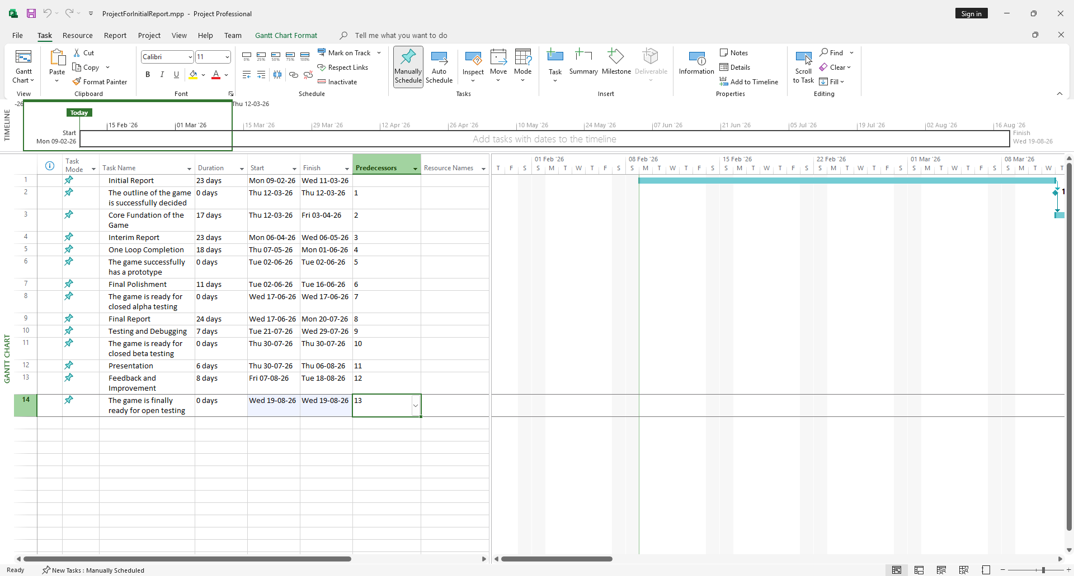

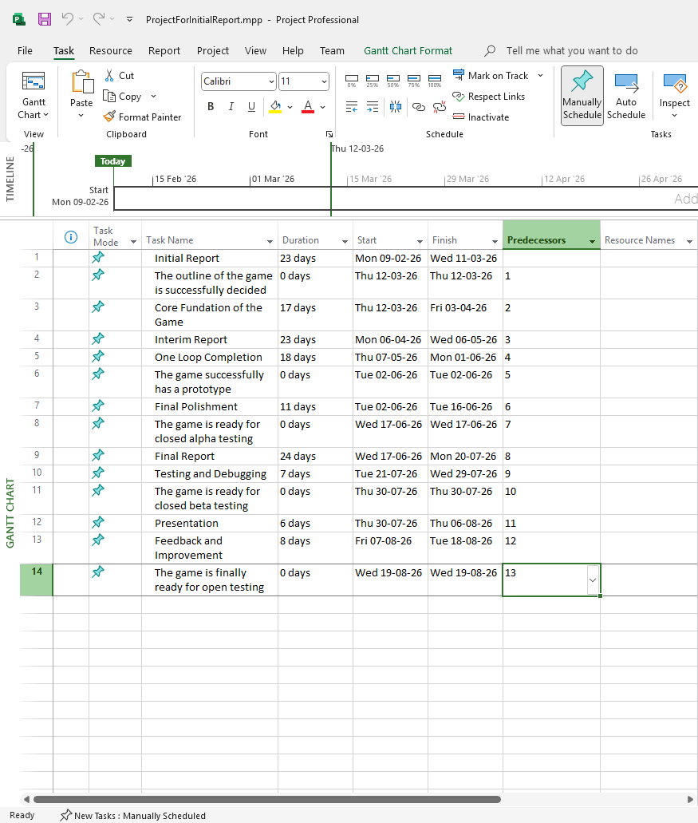

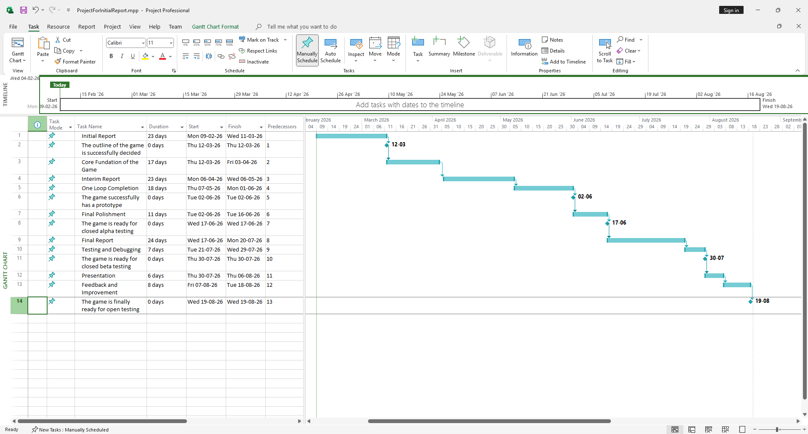

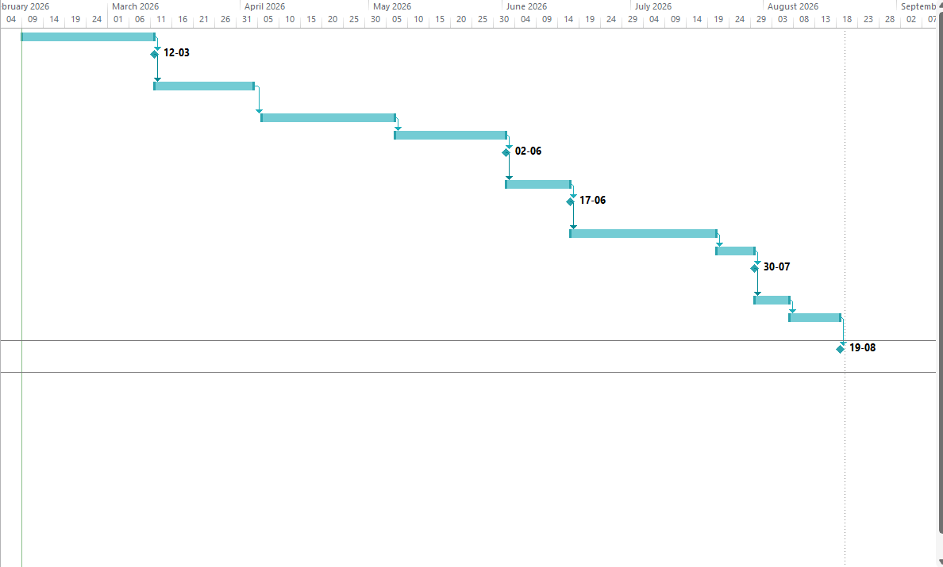

Milestone description:

The outline of the game is successfully decided (12-03-26):

This milestone is established after the initial report is accomplished. After reading the initial report, readers will know the target players, the background story, the genre and the final goal of this game.

The game successfully has a prototype (02-06-26):

This milestone is established after one loop of the game is completed. After this milestone, we can finally try to experience the actual game. Then, try to figure out where it can be improved by adding on more pictures or story-telling.

The game is ready for closed alpha testing(17-06-26):

This milestone is established after the final polishment of the game. After this milestone, we can finally have the full image of our game Stellar Voyager: Spaceship.
In this stage, our main goal is that we should try our best to discover the bug which may happen in our game.

The game is ready for closed beta testing(30-07-26):

This milestone is established after testing and debugging, but it is before presentation. Therefore, in this stage, we should try our best to polish our game with more captivating pictures and more fluent animation. Additionally, we should be prepared for our presentation in the next step.

The game is finally ready for open testing(19-08-26):

This milestone is established after the feedback and improvement, and mostly importantly, it is the final milestone of our game. It symbolizes the success of our game.

Action Plan for (the Prototype for candidate):
Action Plan:

PROTOTYPE IMPLEMENTATION PLAN (7-8 Weeks)

Week 1-3: Core Foundation

Goal: Playable board with card movement
Chen Yu Shiu + Chan Yat Lok: Basic Unity project with draggable cards to move ship between connected nodes

Fung Shing Chun: Create 3 node types (mining, combat, special) with clear visual differences

Cou Tsz Shing: Implement simple UI for cards, timer, ship status
Deliverable by Friday: Can drag a "Move" card to advance 1 node

Week 3-6: Core Loop Complete

Goal: Complete one "sector" (10-15 nodes) with win/lose conditions
Chen Yu Shiu: Implement all card types, combat system (simple HP math), timer effects

Chan Yat Lok: Build sector generation (procedural or pre-made), saving/loading run state

Fung Shing Chun: Polish visuals, create simple tutorial text

Cou Tsz Shing: Add feedback (particles on mining, flashing on combat)

Deliverable by Friday: Can play from start to mini-boss with all card types

Week 6-8: Polish & Test

Goal: Ready for external playtesting
All: Bug fixing, balance tweaking

Fung Shing Chun: Prepare playtesting script and feedback forms

Chen Yu Shiu: Add simple progression (upgrade 1 card after sector)

Chan Yat Lok: Optimize performance, ensure builds work on test machines

Deliverable: Prototype ready for 5-10 external testers

Feedback:
PROTOTYPE FEEDBACK WE NEED

Critical Questions (About the Core Risk):

-Time Pressure Feel: "Did the timer make you feel strategically rushed or just stressed?"
-Card Satisfaction: "When you played a card, did it feel like a meaningful choice or just clicking?"
-Learning Curve: "After 3 failed runs, did you understand WHY you failed and what to try next?"

Specific Mechanics to Test:

-"Time Extend" Card Usage: Do players save it for emergencies or use it immediately?
-Movement vs. Action Trade-off: Do players prioritize reaching the boss or gathering resources?
-Combat Avoidance: Do players avoid combat nodes (risk) or engage (reward)?

Usability Feedback:

-UI Clarity: Could players immediately understand their cards, timer, and ship status?
-Visual Feedback: Did they notice when their mining succeeded? When they took damage?
-Tutorial Effectiveness: Could they start playing without explanation?

Fun Factor Metrics:

-Run Attempts: How many times did testers voluntarily replay after losing?
-Session Length: Did they naturally play for 20+ minutes or quit after 5?
-"One More Run": After finishing a sector, did they want to try again immediately?

Appendices:
Workload Distribution:
Chan Yat Lok (Unity Programmer + Modeler, Report Writer)

Primary Role: Technical Implementation & Documentation
Tasks:
Build the core Unity scene: Create a simple grid/hex map with 20-30 nodes
Implement basic card system: Create card UI that can be dragged/dropped
Build the timer system: Visual countdown that affects gameplay
Document all technical decisions for the report
Create placeholder 3D ship model (simple) and basic space background
Best Used For: Following clear specifications, implementing working systems, creating visual polish for UI and basic 3D.

Chen Yu Shiu (Lead Programmer, Animator, Game Designer)

Primary Role: Game Logic & System Design
Tasks:
Design the prototype's card set (8-12 cards total):
3 Movement cards (Forward, Left, Right)
3 Action cards (Mine, Scan, Repair)
2 Combat cards (Attack, Defend)
2 Special cards (Emergency Burn, Time Extend)
Program the game logic: Card effects, node interactions, win/lose conditions
Design the "time pressure" balancing: How much time per node? How to extend?
Create basic ship animations: Moving between nodes, simple attack animation
Best Used For: Core gameplay programming, balancing numbers, animating key feedback.

Fung Shing Chun (3D Artist, Presenter, Report Writer)

Primary Role: Visual Polish & User Testing Coordination
Tasks:
Create prototype UI wireframes (simple, clean)
Make 3-4 different "node" types visually distinct:
Asteroid (mining)
Space station (shop/repair)
Alien ship (combat)
Nebula (special event)
Lead playtesting sessions and gather feedback
Write the "player experience" section of the prototype report
Best Used For: Making things look good, explaining the game to testers, structured reporting.

Cou Tsz Shing (Support Programmer & Modeler)

Primary Role: Support & Content Creation
Tasks:
Create simple particle effects: Mining sparks, ship engine trail, combat hits
Implement sound system placeholder with basic SFX
Build additional card variations once core is working
Help with bug testing and edge cases
Create enemy placeholder models (simple sphere with different colors)
Best Used For: Supporting technical tasks, creating additional content once foundation is solid.

Budget Estimation:

Category | Cost (HKD) | Notes
Team Costs | $0 | Academic project, no salaries
Software | $2000 | Basic tools only
Assets | $2000 | Minimal purchases
Marketing | $780 | Steam fee only
Hardware | $0 | Use existing equipment
Contingency | $1000
Total | $5780

References:

https://www.facebook.com/playersclub751/
https://steamdeckhq.com/news/the-20-most-played-games-on-the-steam-deck-in-2024/
https://b23.tv/lq4ALZX
https://store.steampowered.com/app/646570/Slay_the_Spire/
https://store.steampowered.com/app/212680/FTL_Faster_Than_Light/
https://store.steampowered.com/app/1102190/Monster_Train/

